**Medicine Recommendation Test Cases:**

1. Pimple
2. Heart attack
3. Headache

**OUTPUT**

1)

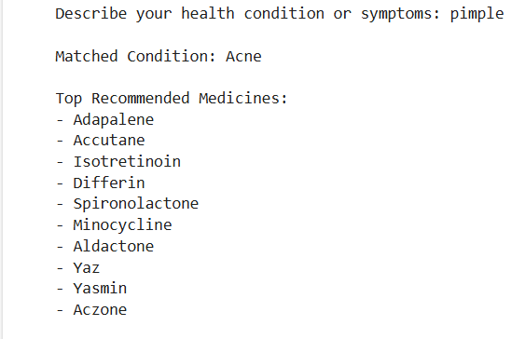

2)

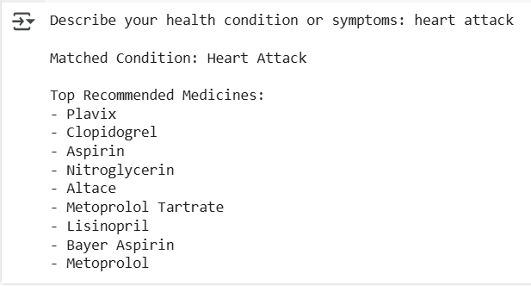

3)

